

In [1]:

1

2

3

4

5

6

**import** numpy **as** np

**import** pandas **as** pd

**import** matplotlib.pyplot **as** plt

**import** seaborn **as** sns

In [2]:

1

2

3

4

data **=** pd.read_csv('D:\IBM PROJECT\dataset/abalone.csv')

*# getting the shape*

data.shape

Out[2]: (4177, 9)

In [3]:

1 data.head() 2

Out[3]:

**Sex Length Diameter Height Whole**

**weight**

**Shucked weight**

**Viscera weight**

**Shell weight**

**Rings**

**0** M 0.455 0.365 0.095 0.5140 0.2245 0.1010 0.150 15

**1** M 0.350 0.265 0.090 0.2255 0.0995 0.0485 0.070 7

**2** F 0.530 0.420 0.135 0.6770 0.2565 0.1415 0.210 9

**3** M 0.440 0.365 0.125 0.5160 0.2155 0.1140 0.155 10

**4** I 0.330 0.255 0.080 0.2050 0.0895 0.0395 0.055 7

In [4]:

1 data.describe()

Out[4]:

**Length Diameter Height Whole**

**weight**

**Shucked weight**

**Viscera weight**

**Shell weight**

**count** 4177.000000 4177.000000 4177.000000 4177.000000 4177.000000 4177.000000 4177.000000

**mean** 0.523992 0.407881 0.139516 0.828742 0.359367 0.180594 0.238831

**std** 0.120093 0.099240 0.041827 0.490389 0.221963 0.109614 0.139203

**min** 0.075000 0.055000 0.000000 0.002000 0.001000 0.000500 0.001500

**25%** 0.450000 0.350000 0.115000 0.441500 0.186000 0.093500 0.130000

**50%** 0.545000 0.425000 0.140000 0.799500 0.336000 0.171000 0.234000

**75%** 0.615000 0.480000 0.165000 1.153000 0.502000 0.253000 0.329000

**max** 0.815000 0.650000 1.130000 2.825500 1.488000 0.760000 1.005000



In [5]:

1 data.info()

<class 'pandas.core.frame.DataFrame'> RangeIndex: 4177 entries, 0 to 4176

Data columns (total 9 columns):

# Column Non-Null Count Dtype

1. Sex 4177 non-null object
2. Length 4177 non-null float64
3. Diameter 4177 non-null float64
4. Height 4177 non-null float64
5. Whole weight 4177 non-null float64
6. Shucked weight 4177 non-null float64
7. Viscera weight 4177 non-null float64
8. Shell weight 4177 non-null float64
9. Rings 4177 non-null int64 dtypes: float64(7), int64(1), object(1)

memory usage: 293.8+ KB

In [6]:

1 data.isnull().sum()

Out[6]: Sex 0

Length 0

Diameter 0

Height 0

Whole weight 0

Shucked weight 0

Viscera weight 0

Shell weight 0

Rings 0

dtype: int64



In [7]:

1 data.isnull()

Out[7]:

**Sex Length Diameter Height Whole**

**weight**

**Shucked weight**

**Viscera weight**

**Shell weight**

**Rings**

* 1. False False False False False False False False False
  2. False False False False False False False False False
  3. False False False False False False False False False
  4. False False False False False False False False False
  5. False False False False False False False False False

**...** ... ... ... ... ... ... ... ... ...

**4172** False False False False False False False False False **4173** False False False False False False False False False **4174** False False False False False False False False False **4175** False False False False False False False False False **4176** False False False False False False False False False

4177 rows × 9 columns



In [8]:

1 sns.pairplot(data)

Out[8]: <seaborn.axisgrid.PairGrid at 0x24972beac70>

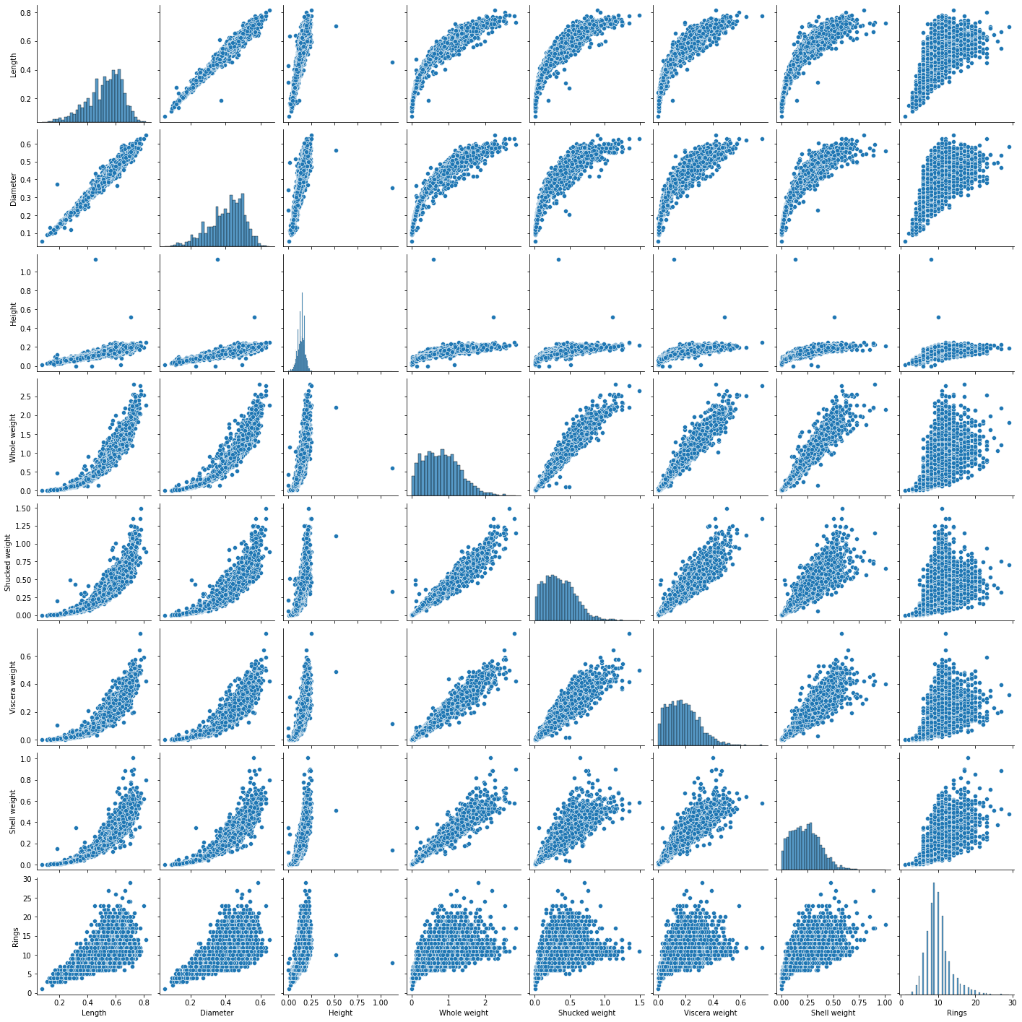



In [9]:

1 data.columns 2

Out[9]: Index(['Sex', 'Length', 'Diameter', 'Height', 'Whole weight', 'Shucked weight', 'Viscera weight', 'Shell weight', 'Rings'],

dtype='object')

In [10]:

1

1. sns.heatmap(data[[ 'Length', 'Diameter', 'Height', 'Whole weight', 'Shucked
2. 'Viscera weight', 'Shell weight', 'Rings']])

Out[10]: <AxesSubplot:>

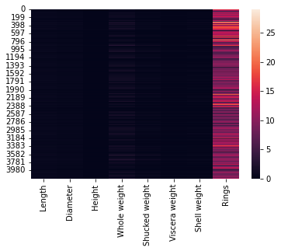

In [11]:

1 data['Sex'].value_counts()

Out[11]: M 1528

I 1342

F 1307

Name: Sex, dtype: int64



In [12]:

1. plt.rcParams['figure.figsize'] **=** (18, 8)
2. sns.boxplot(x**=**data['Rings'], y**=**data['Length'], hue **=** data['Sex'], palette **=**
3. plt.title('Rings vs length and sex', fontsize **=** 20)

Out[12]: Text(0.5, 1.0, 'Rings vs length and sex')

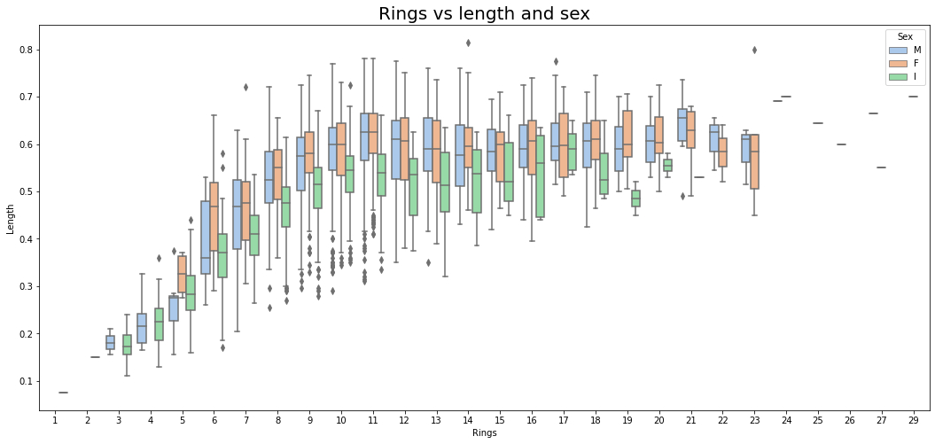

In [13]:

1. plt.rcParams['figure.figsize'] **=** (20, 8)
2. sns.violinplot(x**=**data['Rings'], y**=**data['Diameter'], hue **=** data['Sex'], palet
3. plt.title('Rings vs diameter and sex', fontsize **=** 20)

Out[13]: Text(0.5, 1.0, 'Rings vs diameter and sex')

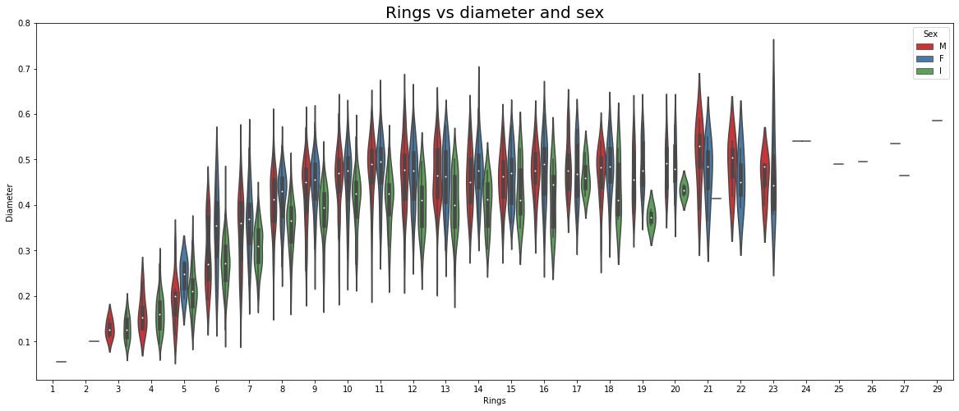



In [14]:

1. plt.rcParams['figure.figsize'] **=** (18, 8)
2. sns.boxenplot(x**=**data['Rings'], y**=**data['Height'], hue **=** data['Sex'], palette
3. plt.title('Rings vs height and sex', fontsize **=** 20)

Out[14]: Text(0.5, 1.0, 'Rings vs height and sex')

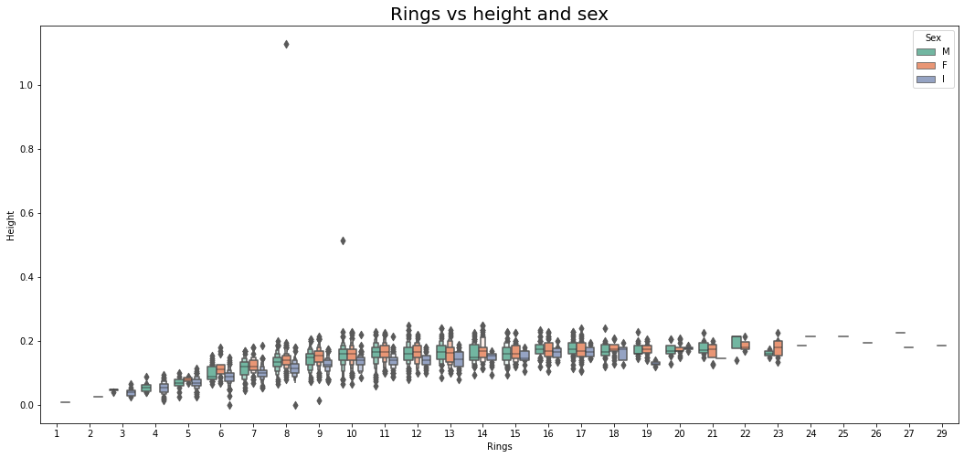



In [15]:

1. plt.rcParams['figure.figsize'] **=** (18, 10)
2. sns.stripplot(x**=**data['Rings'], y**=**data['Whole weight'])
3. plt.title('Rings vs weight')

Out[15]: Text(0.5, 1.0, 'Rings vs weight')

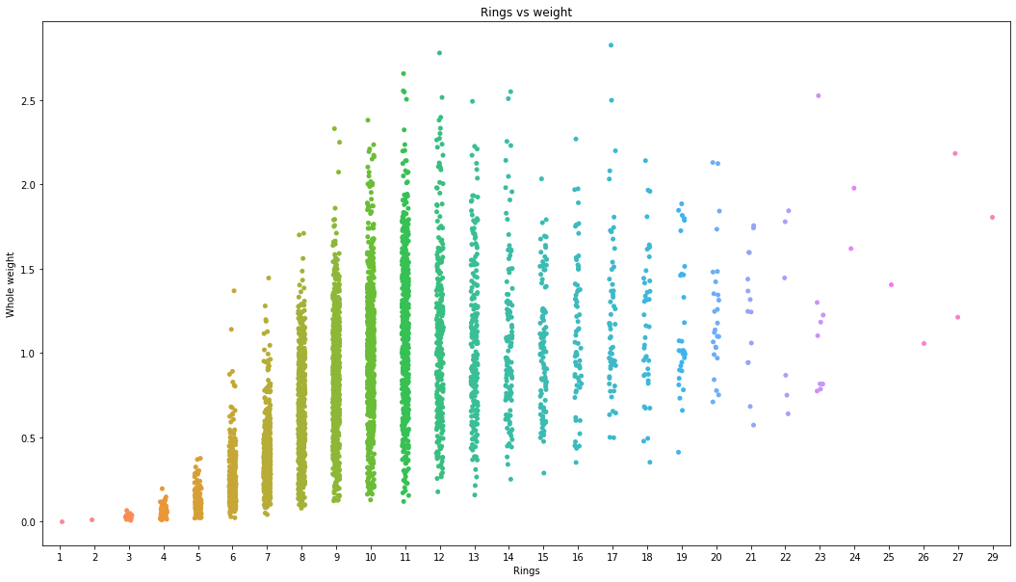

In [16]:

1. plt.rcParams['figure.figsize'] **=** (18, 10)
2. sns.stripplot(x**=**data['Rings'], y**=**data['Shucked weight'], palette **=** 'dark')
3. plt.title('Rings vs shucked weight')

Out[16]: Text(0.5, 1.0, 'Rings vs shucked weight')

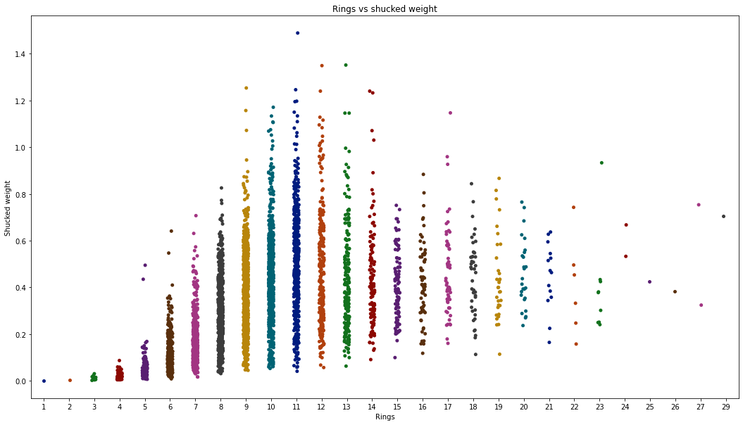



In [17]:

1. plt.rcParams['figure.figsize'] **=** (18, 10)
2. sns.stripplot(x**=**data['Rings'], y**=**data['Viscera weight'])
3. plt.title('Rings vs Viscera Weight')

Out[17]: Text(0.5, 1.0, 'Rings vs Viscera Weight')

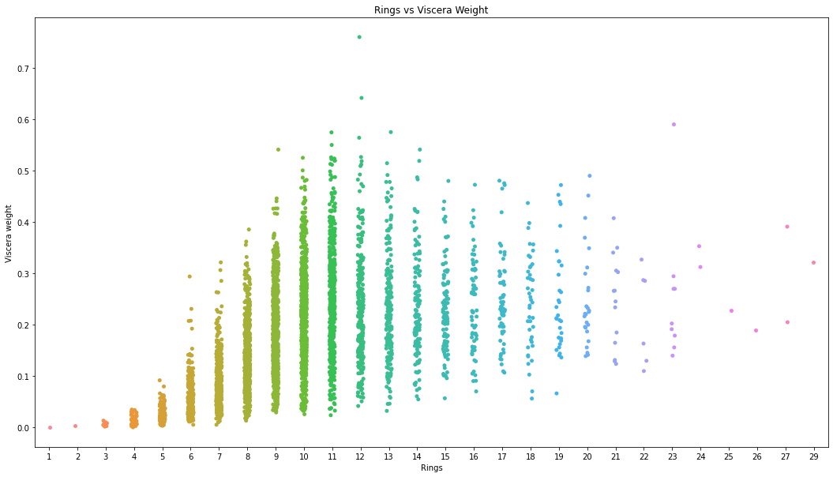



In [18]:

1. plt.rcParams['figure.figsize'] **=** (18, 10)
2. sns.regplot(x**=**data['Rings'], y**=**data['Shell weight'])
3. plt.title('Rings vs Shell weight')

Out[18]: Text(0.5, 1.0, 'Rings vs Shell weight')

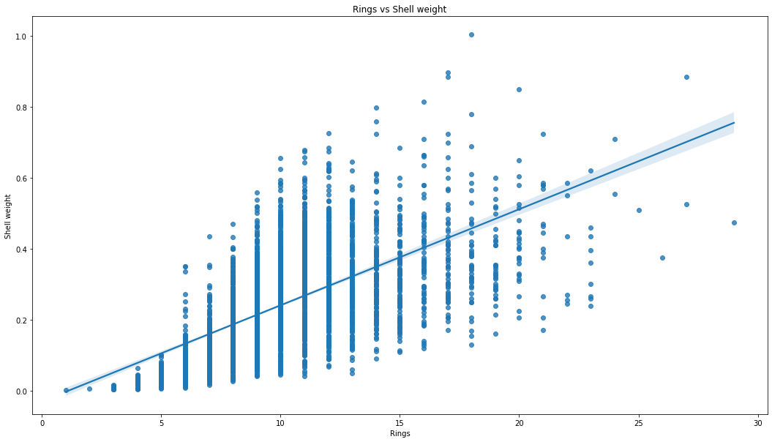



In [19]:

1 **from** math **import** pi 2

1. *# Set data*
2. df **=** pd.DataFrame({
3. 'group': [i **for** i **in** range(0, 4177)],
4. 'Sex': data['Sex'],
5. 'Length': data['Length'],
6. 'Diameter': data['Diameter'],
7. 'Whole weight': data['Whole weight'],
8. 'Viscera weight': data['Viscera weight'],
9. 'Shell weight': data['Shell weight'] 12 })

13

1. *# number of variable*
2. categories**=**list(df)[1:]
3. N **=** len(categories) 17
4. *# We are going to plot the first line of the data frame.*
5. *# But we need to repeat the first value to close the circular graph:*
6. values **=** df.loc[0].drop('group').values.flatten().tolist()
7. values **+=** values[:1]
8. values 23
9. *# What will be the angle of each axis in the plot? (we divide the plot / num*
10. angles **=** [n **/** float(N) **\*** 2 **\*** pi **for** n **in** range(N)]
11. angles **+=** angles[:1] 27
12. *# Initialise the spider plot*
13. ax **=** plt.subplot(111, polar**=True**) 30
14. *# Draw one axe per variable + add labels labels yet*
15. plt.xticks(angles[:**-**1], categories, color**=**'grey', size**=**8) 33
16. *# Draw ylabels*
17. ax.set_rlabel_position(0)

36 plt.yticks([10,20,30], ["10","20","30"], color**=**"grey", size**=**7)

37 plt.ylim(0,40) 38

1. *# Plot data*
2. ax.plot(angles, values, linewidth**=**1, linestyle**=**'solid')
3. plt.title('Radar Chart for determing Importances of Features', fontsize **=** 20
4. *# Fill area*
5. ax.fill(angles, values, 'red', alpha**=**0.1)

Out[19]: [<matplotlib.patches.Polygon at 0x24979ee2940>]

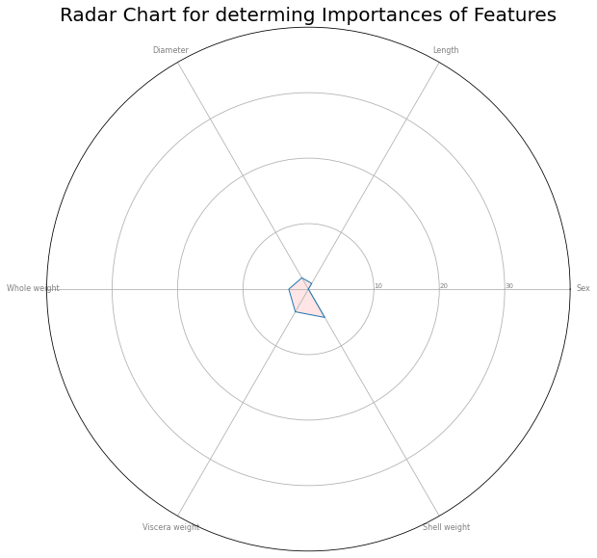



In [20]:

1 data **=** pd.get_dummies(data)



In [21]:

1

2 data.head()

Out[21]:

**Length Diameter Height Whole**

**weight**

**Shucked weight**

**Viscera weight**

**Shell weight**

**Rings Sex_F Sex_I Sex_M**

**0** 0.455 0.365 0.095 0.5140 0.2245 0.1010 0.150 15 0 0 1

**1** 0.350 0.265 0.090 0.2255 0.0995 0.0485 0.070 7 0 0 1

**2** 0.530 0.420 0.135 0.6770 0.2565 0.1415 0.210 9 1 0 0

**3** 0.440 0.365 0.125 0.5160 0.2155 0.1140 0.155 10 0 0 1

**4** 0.330 0.255 0.080 0.2050 0.0895 0.0395 0.055 7 0 1 0

In [22]:

1

2

3

4

5

6

7

y **=** data['Rings']

data **=** data.drop(['Rings'], axis **=** 1) x **=** data

*# getting the shapes*

print("Shape of x:", x.shape) print("Shape of y:", y.shape)

Shape of x: (4177, 10) Shape of y: (4177,)

In [23]:

1

2

3

4

5

6

7

8

9

**from** sklearn.model_selection **import** train_test_split

x_train, x_test, y_train, y_test **=** train_test_split(x, y, test_size **=** 0.2, r

*# getting the shapes*

print("Shape of x_train :", x_train.shape) print("Shape of x_test :", x_test.shape)

print("Shape of y_train :", y_train.shape) print("Shape of y_test :", y_test.shape)

Shape of x_train : (3341, 10)

Shape of x_test : (836, 10) Shape of y_train : (3341,) Shape of y_test : (836,)



In [24]:

1

2

3

4

5

6

7

8

9

10

11

12

13

14

15

16

**from** sklearn.ensemble **import** RandomForestClassifier

**from** sklearn.metrics **import** mean_squared_error

**from** sklearn.metrics **import** r2_score

model **=** RandomForestClassifier()

model.fit(x_train, y_train)

y_pred **=** model.predict(x_test)

*# evaluation*

mse **=** mean_squared_error(y_test, y_pred) rmse **=** np.sqrt(mse)

print("RMSE :", rmse)

*# r2 score*

r2 **=** r2_score(y_test, y_pred) print("R2 Score :", r2)

RMSE : 2.5539630523418446

R2 Score : 0.39939775195158833

In [25]:

1 **!**pip install eli5

Requirement already satisfied: eli5 in c:\users\write\anaconda3\lib\site-packag es (0.13.0)

Requirement already satisfied: six in c:\users\write\anaconda3\lib\site-package s (from eli5) (1.16.0)

Requirement already satisfied: scikit-learn>=0.20 in c:\users\write\anaconda3\l ib\site-packages (from eli5) (1.0.2)

Requirement already satisfied: graphviz in c:\users\write\anaconda3\lib\site-pa ckages (from eli5) (0.20.1)

Requirement already satisfied: tabulate>=0.7.7 in c:\users\write\anaconda3\lib

\site-packages (from eli5) (0.8.9)

Requirement already satisfied: jinja2>=3.0.0 in c:\users\write\anaconda3\lib\si te-packages (from eli5) (3.1.2)

Requirement already satisfied: numpy>=1.9.0 in c:\users\write\anaconda3\lib\sit e-packages (from eli5) (1.21.5)

Requirement already satisfied: scipy in c:\users\write\anaconda3\lib\site-packa ges (from eli5) (1.7.3)

Requirement already satisfied: attrs>17.1.0 in c:\users\write\anaconda3\lib\sit e-packages (from eli5) (21.4.0)

Requirement already satisfied: MarkupSafe>=2.0 in c:\users\write\anaconda3\lib

\site-packages (from jinja2>=3.0.0->eli5) (2.0.1)

Requirement already satisfied: joblib>=0.11 in c:\users\write\anaconda3\lib\sit e-packages (from scikit-learn>=0.20->eli5) (1.1.0)

Requirement already satisfied: threadpoolctl>=2.0.0 in c:\users\write\anaconda3

\lib\site-packages (from scikit-learn>=0.20->eli5) (2.2.0)



In [26]:

1

2

3

4

5

**import** eli5

**from** eli5.sklearn **import** PermutationImportance

perm **=** PermutationImportance(model, random_state **=** 0).fit(x_test, y_test)

eli5.show_weights(perm, feature_names **=** x_test.columns.tolist())



Out[26]: **Weight Feature**

0.0388 ± 0.0399 Shell weight

0.0297 ± 0.0231 Shucked weight

0.0172 ± 0.0110 Length

0.0160 ± 0.0113 Viscera weight

0.0084 ± 0.0062 Height

0.0072 ± 0.0086 Sex_I

-0.0014 ± 0.0111 Sex_F

-0.0019 ± 0.0135 Whole weight

-0.0048 ± 0.0079 Sex_M

-0.0077 ± 0.0120 Diameter

In [ ]:

1

